**Software Requirements and Design Document**

**For**

**Group 11**

Version 2.0

**Authors**:

Tristan F

Kiara B

Jared R

Kaedon H

Jeffrey M

# **1.** **Overview**

The KitchGym is a fitness/health mobile app that allows you to record your old workouts as well as create new ones. The results of these workouts can then transfer over to the health portion of the app where meals can be created depending on your required calorie intake.

# **2.** **Functional Requirements**

**High Priority**

1. Users must be able to create custom workouts by choosing their target muscle groups. Then, exercises matching those muscle groups will be retrieved from the database where they are stored.
2. Users must be able to save their created workouts and view them later by pressing the “View Workouts” button on the Gym homepage.
3. Users must be able to search for recipes that fit within their caloric limit by inputting ingredients.
4. App must be able to calculate the calorie count of food that the user inputs via the “Input Meal” button.
5. App must include a calorie tracker.
6. App must be able to track all of the meals a user inputs.

**Medium Priority**

1. App must be able to suggest food to reach a user’s daily caloric goal.
2. Homepage must display a visual progress report that includes weight changes, average calories burned per workout, and the average time spent per workout.

**Low Priority**

1. Make app look nice (color scheme, animations, icons, etc)

# **3.** **Non-functional Requirements**

1. The App should be accessible to people with vision issues by implementing an audio screen reader, a large font option to make the font at least 50% larger, and a screen magnifier that will magnify the selected area by 50%.
2. The App should be accessible for people with color blindness. This can be done by making sure any information represented through color (like a pie chart) is also stated through other means, such as text.
3. All data will be stored in remote Firebase as to lessen the amount of local storage.
4. App should be able to run on Android version 4.0.3 and up. Android 10 will be the target development version.
5. APIs will be used to create workouts and meals. (Recipe Puppy, TheMealDB, Nutritionx, Wger).
6. In the event that an API or database is unable to be accessed, the user will be notified by an error message.
7. Users will receive notifications reminding them to work out and eat. Can be disabled.
8. App should be able to launch in under 5 seconds on a cold start. Transitions between activities should be less than one second.
9. Any caloric calculations will be rounded to the nearest whole number.
10. Weight calculations will be rounded to the nearest tenth of a pound or kilogram.
11. Time spent working out will be rounded to the nearest second.
12. App will be $0.00.
13. Users will be able to utilize this app for the duration of their fitness journey (as long as it takes to meet their goal weight).

# **4.** **Use Case Diagram**



1. Name: Create Workout
2. Participating actors: User, Exercise API
3. Entry condition:
   1. User presses “Create Workout”
4. Exit condition:
   1. Workout is generated
5. Flow of events:
   1. User presses “Create Workout”
   2. User checks target muscle groups for this workout
   3. KitchGym calls Exercise API (Wger) and retrieves exercises matching the desired muscle groups
   4. Workout is generated and displayed to User
   5. User does the workout
6. Special requirements: None.
7. Name: Input Meal
8. Participating actors: User, Nutrition API
9. Entry condition:
   1. User presses “Input Meal”
10. Exit condition:
    1. Calories are re-calculated
11. Flow of events:
    1. User presses “Input Meal”
    2. User searches for food item and inputs amount of that item
    3. KitchGym calls Nutrition API to retrieve calories for the food eaten
    4. Total calories is re-calculated and displayed for the User on the Kitchen homepage
12. Special requirements: None.
13. Name: View Workout
14. Participating actors: User
15. Entry condition:
    1. User presses “View Workouts”
16. Exit condition:
    1. Workouts are displayed
17. Flow of events:
    1. User presses “View Workouts”
    2. Saved workouts are displayed on another page
18. Special requirements: None.

**5.** **Class Diagram and/or Sequence Diagrams**

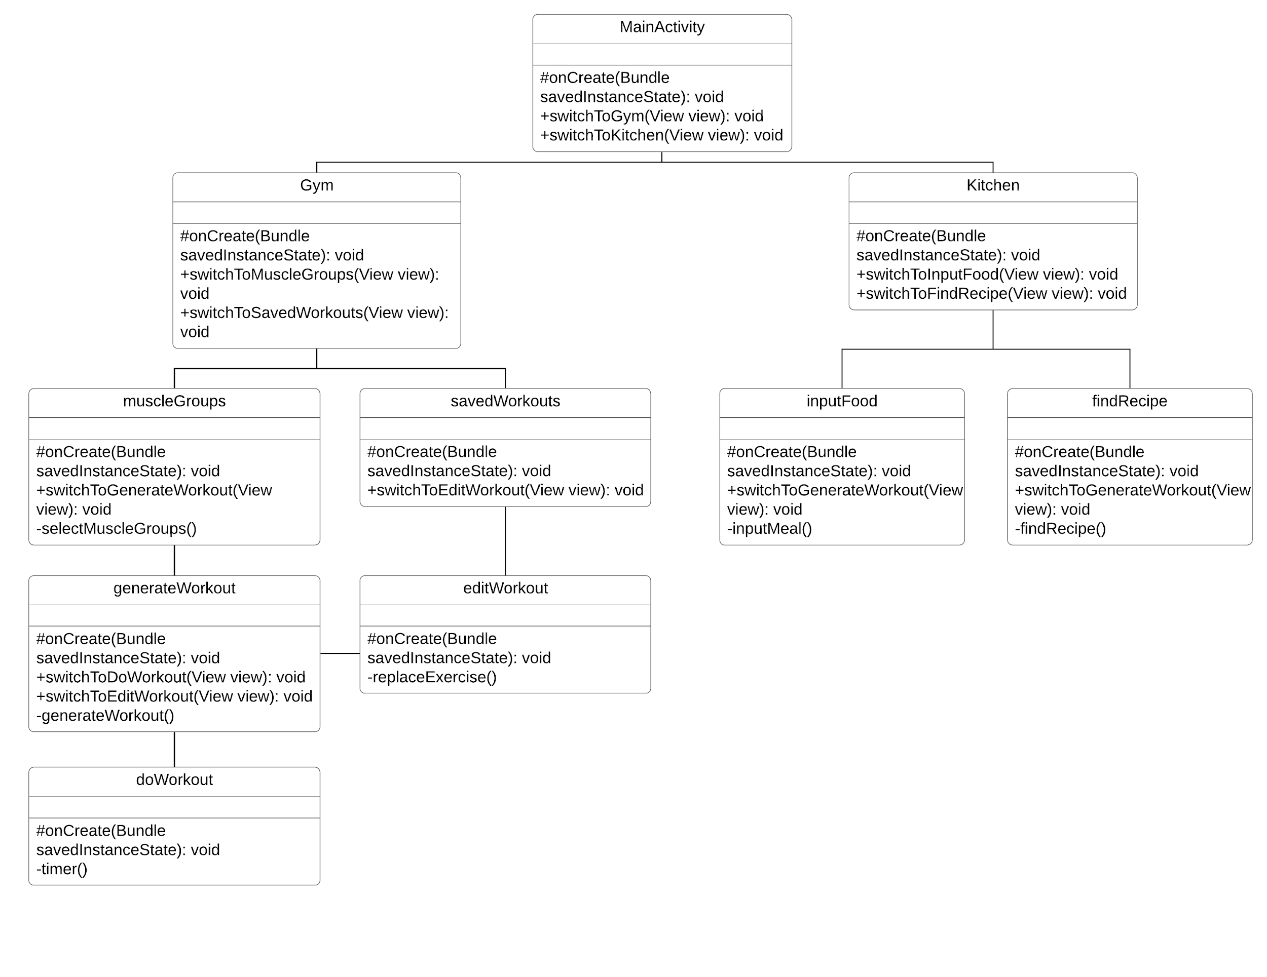

# 

# **6.** **Operating Environment**

The application will operate on an Android device. The minimum OS would be API 15: Android 4.0.3 (IceCreamSandwich). This environment was chosen because it allows the application to run on 100% of devices, according to Android Studio.

# **7.** **Assumptions and Dependencies**

* The devices being used are Android and that the device’s operating system is up-to-date, or at least Android 4.0.3
* The utilized APIs are going to stay public
* The user’s device will be able to connect to the internet when using the KitchGym
* The users will only want to work out the main muscle groups, and have knowledge of basic exercises such as: bicep curls, bench press, etc.
* Users actively input their calorie intake in order to accurately calculate calories
* Firebase google-services.json added to the app, along with a number of Firebase dependencies in the build Gradle.